CS3307 Learning Journal 8

Here I am creating a GUI for a hypothetical operating system.

I am concerned about the fundamental functions of the GUI.

1. The flexibility of managing peripheral devices like Bluetooth, WIFI, monitor, and input devices.
2. The ease of usage of file management.
3. The ease of usage of application management.
4. The ease of managing multiple tasks at the same time like a taskbar.

Besides the most fundamental functions of having a GUI for the operating system.

According to (GUI Design Principles - Wikibooks, Open Books for an Open World, n.d.), a Few more other things can be incorporated into the GUI design to achieve a user-friendly, efficient, and visually appealing experience:

Streamlined and Minimalistic Design: Embrace a clean and minimalistic design approach, focusing on simplicity and decluttering the interface. Use ample white space, clear typography, and intuitive icons to create a visually pleasing and uncluttered interface.

Intuitive Navigation: Design an intuitive and efficient navigation system that allows users to easily access applications, settings, and features. Implement clear and well-organized menus, search functionality, and gestures to provide quick and seamless navigation.

Customizability: Offer users a degree of customization to personalize their interface. Allow them to choose layout options to create a GUI that suits their preferences and enhances their productivity.

According to (*The 6 Key Principles of UI Design | Maze*, n.d.), Intelligent Task Management: Incorporate intelligent task management features that facilitate multitasking and help users stay organized. Implement features like virtual desktops, window snapping, and a taskbar that displays relevant information and notifications.

Contextual Awareness: Create a GUI that is contextually aware of user actions and dynamically adapts to provide relevant information and options. For example, based on the current task or application, the interface can intelligently display context-specific tools or suggestions to streamline user workflows.

Smart Notifications and Alerts: Implement a smart notification system that delivers timely and relevant notifications to users without overwhelming them. Use machine learning algorithms to learn user preferences and adjust the notification delivery accordingly.

The final total design is as below image.

At the top left corner, I introduced the **desktop tabs.** It helps multiple task management.

It allows users to quickly switch between the context of tasks. The user can keep one set of work on desktop 1 for administration relating tasks like email and Word. Then use the second desktop to perform development relating tasks like coding and compiling.

This segregation helps to reduce the chance of closing windows by accident.

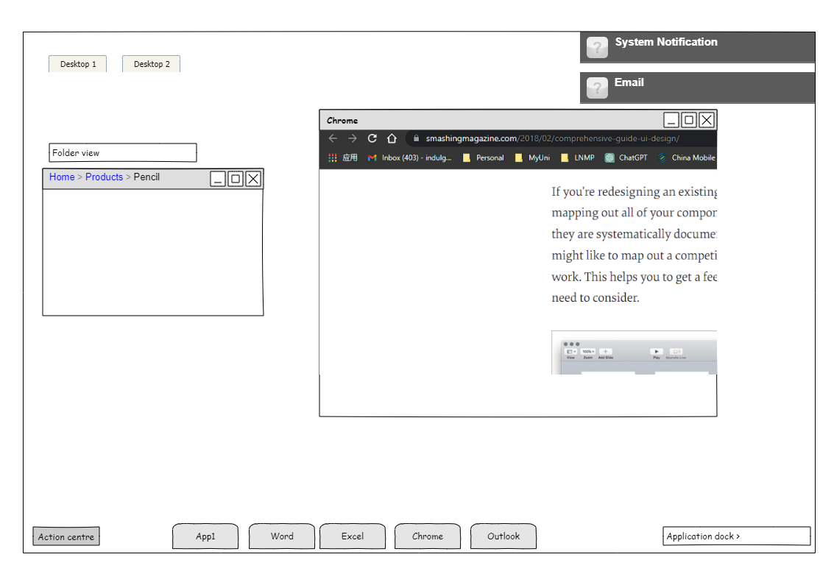

At the top right corner, I introduced the notification area. The interaction between the user and the system is crucial for a modern system. This area can be used to show notifications, reminders, system errors, and many more.

By clicking the notification, the user can navigate to the responding application or source of information. It helps the user to interact with the system.

From the left of the bottom of the screen, I put one action center to the button, it will prompt a list of actions of the system including the power options like shutting down the system. the opened application will be kept in the middle of the bottom of the screen for users to navigate between them.

On the rightmost bottom, I put the action dock for extra applications or common applications. It helps the user to view recently used apps or documents and locations.

Overall, by incorporating these elements into the GUI design, you can create a user-friendly, efficient, and visually appealing experience that offers a unique and satisfying interaction for users of the hypothetical operating system.

**Reference**

*GUI Design Principles - Wikibooks, open books for an open world*. (n.d.). Retrieved May 28, 2023, from https://en.wikibooks.org/wiki/GUI_Design_Principles

*The 6 Key Principles of UI Design | Maze*. (n.d.). Retrieved May 28, 2023, from https://maze.co/collections/ux-ui-design/ui-design-principles/